**Create a checkbox “isActive” on Opportunity. Write a trigger such that if the Closed date is having today’s date then the isActive checkbox must be true. This scenario must work on the insert as well as on the update. Write a test class for this as well**

**Trigger:**

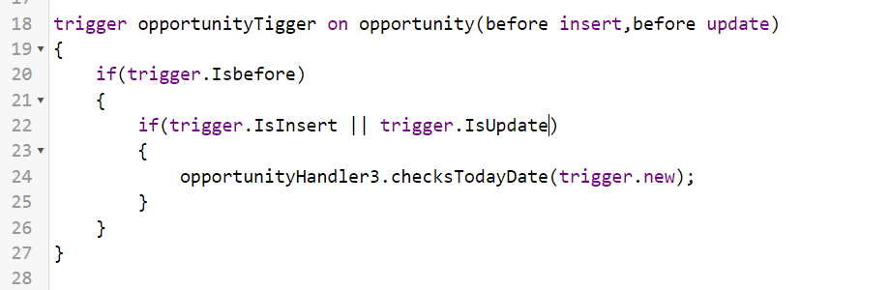

**TriggerHandler:**

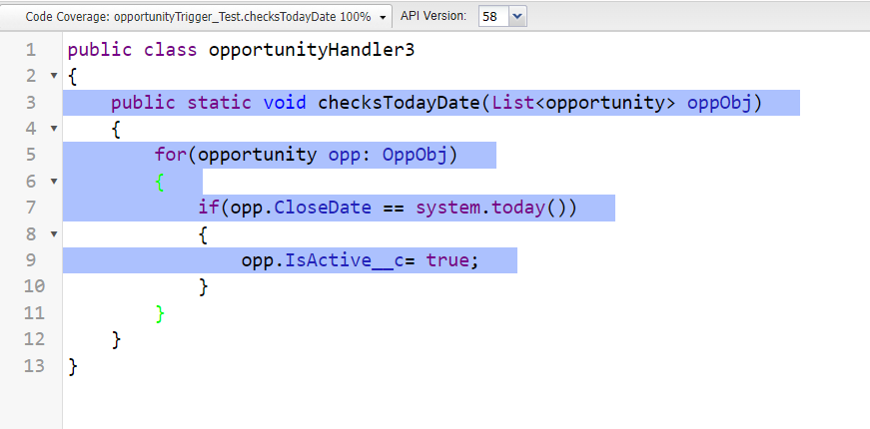

**TriggerHandler_Test**

